Home Recording Guide

- There are 31 rows on each page to allow room for a record of the student’s daily study on each day of the month.
- Worksheets are recorded in date order to indicate the actual sequence in which they were completed, even if this differs from the way in which they were issued.
- There are 14 columns on each page and they are used in the following way:

- Record the day of the month
- Record the worksheet level; e.g. AI (If first page of set is AI 21)
- Record the set number; e.g. 21 (If first page of set is AI 21)
- Record the time taken to complete the worksheets, in minutes
- Record the scores before correction for each page in boxes 1 – 10 e.g. maths score of B, English score of 95

Please ask your Instructor for a copy of The Value of Home Marking: A Guide for Parents for information on marking your child’s worksheets at home. Thank you for recording your child’s work at home. Please email this record sheet to your Instructor as advised.

Sample record sheets
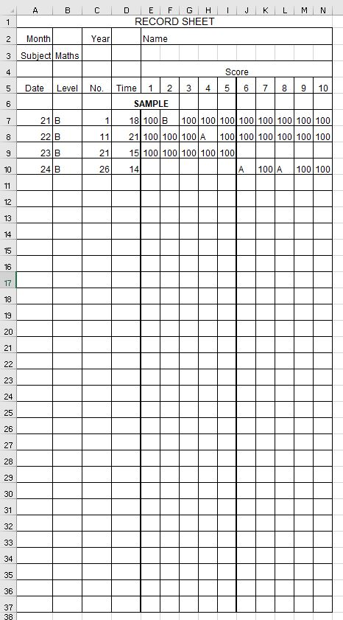
Maths
English
